Chapter 13: Kubernetes Scheduling, Static Pods, Labels, and Selectors

The Kubernetes Scheduler: Role and Workflow
- [01:29 → 03:59]
The scheduler continuously monitors pods in the cluster that are yet to be assigned to nodes. When a new pod creation request is received (e.g., via kubectl), the API server records it in the etcd database. The scheduler then determines the best node based on a scheduling algorithm and various parameters. It instructs the respective kubelet on the chosen node to run the pod. Once the pod is provisioned, the kubelet updates the API server, confirming pod creation.
  - The scheduler is a control plane component running as a pod within the cluster.
  - It is responsible for decision making in pod placement and interacts directly with the API server and kubelets.
  - This scheduling ensures pods are efficiently distributed across worker nodes for optimal resource utilization.

Static Pods: Control Plane Components Managed Outside the Scheduler
- [03:59 → 13:28]
A unique challenge arises because the scheduler itself runs as a pod—who schedules the scheduler? This is resolved by the concept of static pods.
- Static pods are pods that are managed directly by the kubelet on a node, not by the scheduler.
- They are typically used for control plane components like the API server, controller manager, and scheduler itself.
- These pods are defined by manifest files located in a specific directory (/etc/kubernetes/manifests) on the control plane node.
- The kubelet monitors this directory and launches pods based on the YAML manifests found there.
- Removing a static pod manifest (e.g., the scheduler manifest) causes the pod to stop running; restoring it causes the pod to restart.
- If the scheduler pod is down, new pods remain in a pending state since no scheduling decisions are made. Existing pods continue to run unless they fail.
This mechanism ensures that essential control plane components are always running without depending on the scheduler itself, solving the “chicken and egg” problem.

Manual Scheduling: Assigning Pods to Specific Nodes
- [13:28 → 20:37]
Manual scheduling allows explicit control over where a pod runs by specifying the nodeName field in the pod spec.
- When a pod’s nodeName is set, the scheduler does not intervene; the pod is directly assigned to that node.
- This is useful for critical workloads or specific requirements where pod placement must be predetermined.
- Demonstrations showed deleting the scheduler pod and creating a pod with a nodeName field. Despite the scheduler being down, the pod was scheduled and ran on the specified node.
- This technique bypasses the scheduler’s decision-making and delegates responsibility to the kubelet on the target node.
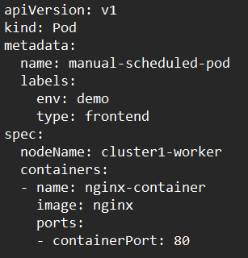
- It is important to delete the existing pod before rescheduling it on a different node, as pods cannot be moved once scheduled.

Labels and Selectors: Organizing and Querying Kubernetes Resources
- [20:37 → 28:31]
Labels and selectors are fundamental Kubernetes features for managing and querying resources.
- Labels are key-value pairs attached to Kubernetes objects (pods, deployments, services, daemonsets, etc.) used to categorize and organize resources.
- Selectors query and filter resources based on their labels.
- Example: A deployment may have a label environment=demo, and it uses a selector to manage pods with the matching label.
- Multiple labels can be added to a pod, such as tier=frontend or type=app1, allowing complex grouping and filtering.
- Commands like kubectl get pods --selector=tier=frontend return only pods with the specified labels, enabling efficient resource management in large clusters.
- Labels are similar to tags or filters used in real-world contexts, such as online shopping filters on Amazon, where products are tagged with multiple attributes for easier selection.
- Annotations differ from labels; they store additional metadata about objects (e.g., last applied configuration, timestamps) that help controllers manage updates and rollbacks but are not used for filtering.

pod with node selector for labeled node
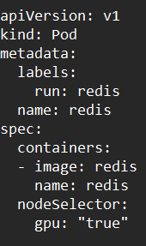

Differentiating Labels and Namespaces
- [27:22 → 28:31]
While both labels and namespaces help organize resources, they serve different functions:
- Namespaces provide logical separation of resources, preventing accidental modifications across environments (e.g., production vs. testing). They are used for security and resource isolation.
- Labels provide flexible tagging of resources within or across namespaces, primarily for filtering, grouping, and management purposes.
- This distinction is critical for designing scalable and secure Kubernetes clusters.

